📘 Java JDBC (Java Database Connectivity) –Notes

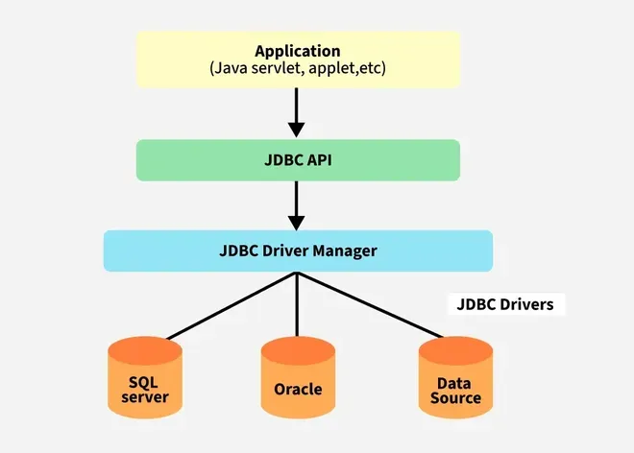

🔹 1. Introduction
JDBC (Java Database Connectivity) is an API (Application Programming Interface) provided by Java to connect and interact with relational databases.
It allows Java applications to perform CRUD operations (Create, Read, Update, Delete) on databases in a platform-independent way.
Package:
import java.sql.*;

🔹 2. What is JDBC?
JDBC is a bridge between Java applications and databases.
It provides classes and interfaces to:
- Connect to a database
- Send SQL queries
- Retrieve and manipulate data

🔹 3. JDBC Architecture
Java Application
|
↓
JDBC API (java.sql)
|
↓
JDBC Driver Manager
|
↓
JDBC Driver
|
↓
Database

Components:
- JDBC API: Provides interfaces and classes to access database features.
- Driver Manager: Manages multiple database drivers.
- Driver: Connects Java application to the database.
- Connection: Interface representing a connection to a database.
- Statement: Used to execute SQL queries.
- ResultSet: Represents the result of a query.

🔹 4. JDBC Drivers

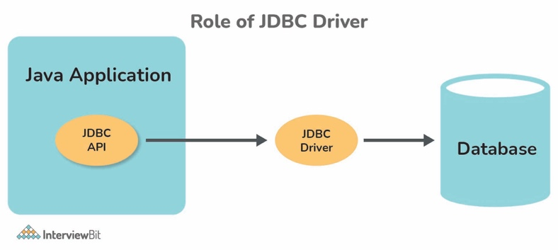
Type | Description | Example
Type 1 | JDBC-ODBC Bridge Driver | sun.jdbc.odbc.JdbcOdbcDriver
Type 2 | Native API Driver | Oracle OCI driver
Type 3 | Network Protocol Driver | Middleware-based driver
Type 4 | Thin Driver (Pure Java) | Oracle Thin, MySQL Connector/J
✅ Recommended: Use Type 4 driver (pure Java, platform-independent).
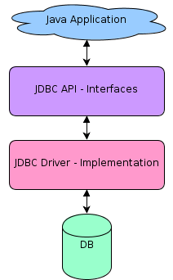

🔹 5. Steps to Use JDBC
Step | Description | Example
1 | Load the Driver class | Class.forName("oracle.jdbc.driver.OracleDriver");
2 | Establish Connection | Connection con = DriverManager.getConnection(url, user, pass);
3 | Create Statement | Statement st = con.createStatement();
4 | Execute Query | ResultSet rs = st.executeQuery("SELECT * FROM student");
5 | Process Results | while(rs.next()) { ... }
6 | Close Connection | con.close();

✅ Basic JDBC MySQL Connection Example

1. Prerequisites
- MySQL is installed and running
- Database name: testdb
- Table name: students (with columns id, name, age)
- MySQL Connector/J JAR is added to your project’s classpath
(e.g., mysql-connector-j-8.0.xx.jar)

2. Java Code
import java.sql.Connection;
import java.sql.DriverManager;
import java.sql.ResultSet;
import java.sql.Statement;
import java.sql.SQLException;

public class JDBCExample {
public static void main(String[] args) {
// Database credentials
String url = "jdbc:mysql://localhost:3306/testdb"; // Replace 'testdb' with your DB name
String user = "root"; // Replace with your MySQL username
String password = "password"; // Replace with your MySQL password

Connection conn = null;
Statement stmt = null;
ResultSet rs = null;

try {
// Step 1: Load and register JDBC driver (optional in newer versions)
Class.forName("com.mysql.cj.jdbc.Driver");

// Step 2: Establish connection
conn = DriverManager.getConnection(url, user, password);
System.out.println("✅ Connected to MySQL database successfully!");

// Step 3: Create statement
stmt = conn.createStatement();

// Step 4: Execute query
String sql = "SELECT id, name, age FROM students";
rs = stmt.executeQuery(sql);

// Step 5: Process results
System.out.println("ID\tName\tAge");
while (rs.next()) {
int id = rs.getInt("id");
String name = rs.getString("name");
int age = rs.getInt("age");
System.out.println(id + "\t" + name + "\t" + age);
}

} catch (ClassNotFoundException e) {
System.out.println("❌ MySQL JDBC Driver not found!");
e.printStackTrace();
} catch (SQLException e) {
System.out.println("❌ Database connection or query failed!");
e.printStackTrace();
} finally {
// Step 6: Close all resources
try {
if (rs != null) rs.close();
if (stmt != null) stmt.close();
if (conn != null) conn.close();
System.out.println("🔒 Connection closed.");
} catch (SQLException e) {
e.printStackTrace();
}
}
}
}

6. Example Code
import java.sql.*;

public class JdbcExample {
public static void main(String[] args) {
try {
// 1. Load Driver
Class.forName("oracle.jdbc.driver.OracleDriver");

// 2. Establish Connection
Connection con = DriverManager.getConnection(
"jdbc:oracle:thin:@localhost:1521:xe", "system", "oracle");

// 3. Create Statement
Statement stmt = con.createStatement();

// 4. Execute Query
ResultSet rs = stmt.executeQuery("SELECT * FROM student");

// 5. Process Result
while (rs.next()) {
System.out.println(rs.getInt(1) + " " + rs.getString(2));
}

// 6. Close Connection
con.close();

} catch (Exception e) {
e.printStackTrace();
}
}
}

🔹 7. Important JDBC Interfaces
Interface | Purpose
Driver | Handles communication with the database.
Connection | Represents a session with the database.
Statement | Used to execute static SQL queries.
PreparedStatement | Used for precompiled SQL queries.
CallableStatement | Used to call stored procedures.
ResultSet | Stores and processes data retrieved from queries.
ResultSetMetaData | Provides information about columns in a ResultSet.
DatabaseMetaData | Provides information about the database itself.

🔹 8. Types of Statements
Type | Description | Example
Statement | Used for static SQL queries. | executeQuery("SELECT * FROM emp");
PreparedStatement | Used for dynamic queries (with parameters). | setString(1, name);
CallableStatement | Used for stored procedures. | prepareCall("{call getSalary(?)}");

🔹 9. Using PreparedStatement

Advantages:
- Prevents SQL Injection
- Faster performance
- Reusable query plan
PreparedStatement ps = con.prepareStatement("INSERT INTO student VALUES(?, ?)");
ps.setInt(1, 101);
ps.setString(2, "Amit");
ps.executeUpdate();

🔹 10. Using CallableStatement
Used to call stored procedures in the database.
CallableStatement cs = con.prepareCall("{call getStudentName(?)}");
cs.setInt(1, 101);
ResultSet rs = cs.executeQuery();

🔹 11. Executing Queries
Method | Use | Return Type
executeQuery() | For SELECT statements | ResultSet
executeUpdate() | For INSERT, UPDATE, DELETE | int (no. of rows affected)
execute() | For any SQL | boolean

🔹 12. ResultSet Methods
Method | Description
next() | Moves to next row
previous() | Moves to previous row
getInt(col) | Retrieves integer value
getString(col) | Retrieves string value
getDate(col) | Retrieves date value

🔹 13. ResultSet Types
Type | Scrollability | Updatability
TYPE_FORWARD_ONLY | Forward only | No
TYPE_SCROLL_INSENSITIVE | Scroll both directions | No
TYPE_SCROLL_SENSITIVE | Scroll both directions | Yes

🔹 14. Handling Transactions
By default, JDBC auto-commits after each SQL statement.
To control manually:
con.setAutoCommit(false);

PreparedStatement ps = con.prepareStatement("UPDATE account SET balance = balance - ? WHERE acc_no = ?");
ps.setInt(1, 1000);
ps.setInt(2, 101);
ps.executeUpdate();

con.commit(); // or con.rollback()

🔹 15. Batch Processing
Execute multiple SQL statements together for better performance.
Statement stmt = con.createStatement();
stmt.addBatch("INSERT INTO student VALUES(101, 'Amit')");
stmt.addBatch("INSERT INTO student VALUES(102, 'Ravi')");
stmt.executeBatch();

🔹 16. JDBC Metadata Interfaces
Interface | Purpose
DatabaseMetaData | Info about database name, driver, version
ResultSetMetaData | Info about result set columns (names, types)

🔹 17. Common JDBC Exceptions
Exception | Cause
SQLException | General database error
SQLSyntaxErrorException | Invalid SQL syntax
SQLIntegrityConstraintViolationException | Violating primary/foreign key
SQLTimeoutException | Query timeout

🔹 18. Closing Resources
Always close resources to avoid memory leaks:
rs.close();
stmt.close();
con.close();
✅ Use try-with-resources (Java 7+) to close automatically.

🔹 19. JDBC in Layered Architecture (Best Practice)
Layer | Description
Bean / Model | Holds data (POJO class)
DAO (Data Access Object) | Contains all JDBC code
Service | Calls DAO methods
UI / Main | Interacts with user

🔹 20. Summary Table
Concept | Description
JDBC | API for connecting Java and databases
DriverManager | Manages database drivers
Connection | Represents DB connection
Statement | Executes SQL queries
PreparedStatement | Executes parameterized queries
CallableStatement | Executes stored procedures
ResultSet | Stores retrieved data
Transaction | Group of SQL statements executed as a unit

Student Management System (CRUD Operations)

🔹 1. Introduction
A Student Management System (SMS) is a simple database-driven application that performs basic CRUD operations:
Operation | Description | SQL Command
C | Create / Insert new student record | INSERT
R | Read / View student details | SELECT
U | Update existing student details | UPDATE
D | Delete student record | DELETE
We use JDBC to connect Java code with a database (like Oracle or MySQL) and execute these operations.

🔹 2. Database Setup Example
Table: student
Column Name | Data Type | Description
sid | INT | Student ID (Primary Key)
sname | VARCHAR(50) | Student Name
course | VARCHAR(50) | Course Name
marks | INT | Total Marks
SQL Command to Create Table:
CREATE TABLE student (
sid NUMBER PRIMARY KEY,
sname VARCHAR2(50),
course VARCHAR2(50),
marks NUMBER
);

🔹 3. JDBC Steps Used
- Load the JDBC Driver
- Establish Connection
- Create SQL Statement or PreparedStatement
- Execute SQL Query
- Process the Result
- Close the Connection

🔹 4. Project Structure (Recommended Layered Architecture)
studentmanagement/
├── bean/
│ └── Student.java
├── dao/
│ └── StudentDAO.java
├── service/
│ └── StudentService.java
├── util/
│ └── DBConnection.java
└── main/
└── StudentMain.java

🔹 5. DBConnection Utility Class
package util;
import java.sql.*;

public class DBConnection {
public static Connection getConnection() {
Connection con = null;
try {
Class.forName("oracle.jdbc.driver.OracleDriver");
con = DriverManager.getConnection(
"jdbc:oracle:thin:@localhost:1521:xe", "system", "oracle");
} catch (Exception e) {
e.printStackTrace();
}
return con;
}
}

🔹 6. Student Bean Class
package bean;

public class Student {
private int sid;
private String sname;
private String course;
private int marks;

// Constructor
public Student(int sid, String sname, String course, int marks) {
this.sid = sid;
this.sname = sname;
this.course = course;
this.marks = marks;
}

// Getters and Setters
public int getSid() { return sid; }
public String getSname() { return sname; }
public String getCourse() { return course; }
public int getMarks() { return marks; }
}

🔹 7. DAO Class (CRUD Operations)
package dao;
import java.sql.*;
import bean.Student;
import util.DBConnection;

public class StudentDAO {

// CREATE
public int insertStudent(Student s) throws SQLException {
Connection con = DBConnection.getConnection();
PreparedStatement ps = con.prepareStatement(
"INSERT INTO student VALUES (?, ?, ?, ?)");
ps.setInt(1, s.getSid());
ps.setString(2, s.getSname());
ps.setString(3, s.getCourse());
ps.setInt(4, s.getMarks());
int i = ps.executeUpdate();
con.close();
return i;
}

// READ
public void displayStudents() throws SQLException {
Connection con = DBConnection.getConnection();
Statement st = con.createStatement();
ResultSet rs = st.executeQuery("SELECT * FROM student");
System.out.println("SID\tNAME\tCOURSE\tMARKS");
while (rs.next()) {
System.out.println(rs.getInt(1) + "\t" + rs.getString(2) + "\t"
+ rs.getString(3) + "\t" + rs.getInt(4));
}
con.close();
}

// UPDATE
public int updateMarks(int sid, int marks) throws SQLException {
Connection con = DBConnection.getConnection();
PreparedStatement ps = con.prepareStatement(
"UPDATE student SET marks=? WHERE sid=?");
ps.setInt(1, marks);
ps.setInt(2, sid);
int i = ps.executeUpdate();
con.close();
return i;
}

// DELETE
public int deleteStudent(int sid) throws SQLException {
Connection con = DBConnection.getConnection();
PreparedStatement ps = con.prepareStatement(
"DELETE FROM student WHERE sid=?");
ps.setInt(1, sid);
int i = ps.executeUpdate();
con.close();
return i;
}
}

🔹 8. Service Class (Optional Layer)
package service;
import dao.StudentDAO;
import bean.Student;

public class StudentService {
StudentDAO dao = new StudentDAO();

public void addStudent(Student s) {
try {
int result = dao.insertStudent(s);
if (result > 0)
System.out.println("Student inserted successfully.");
else
System.out.println("Insertion failed.");
} catch (Exception e) {
e.printStackTrace();
}
}

public void viewStudents() {
try {
dao.displayStudents();
} catch (Exception e) {
e.printStackTrace();
}
}

public void modifyMarks(int id, int marks) {
try {
int result = dao.updateMarks(id, marks);
if (result > 0)
System.out.println("Marks updated successfully.");
else
System.out.println("No such student found.");
} catch (Exception e) {
e.printStackTrace();
}
}

public void removeStudent(int id) {
try {
int result = dao.deleteStudent(id);
if (result > 0)
System.out.println("Student deleted successfully.");
else
System.out.println("Deletion failed.");
} catch (Exception e) {
e.printStackTrace();
}
}
}

🔹 9. Main Class (User Interface)
package main;
import java.util.*;
import bean.Student;
import service.StudentService;

public class StudentMain {
public static void main(String[] args) {
Scanner sc = new Scanner(System.in);
StudentService service = new StudentService();

while (true) {
System.out.println("\n--- Student Management System ---");
System.out.println("1. Add Student");
System.out.println("2. View Students");
System.out.println("3. Update Marks");
System.out.println("4. Delete Student");
System.out.println("5. Exit");
System.out.print("Enter choice: ");
int ch = sc.nextInt();

switch (ch) {
case 1:
System.out.print("Enter ID: ");
int id = sc.nextInt();
System.out.print("Enter Name: ");
String name = sc.next();
System.out.print("Enter Course: ");
String course = sc.next();
System.out.print("Enter Marks: ");
int marks = sc.nextInt();
service.addStudent(new Student(id, name, course, marks));
break;

case 2:
service.viewStudents();
break;

case 3:
System.out.print("Enter Student ID: ");
int sid = sc.nextInt();
System.out.print("Enter New Marks: ");
int newMarks = sc.nextInt();
service.modifyMarks(sid, newMarks);
break;

case 4:
System.out.print("Enter Student ID to Delete: ");
int delId = sc.nextInt();
service.removeStudent(delId);
break;

case 5:
System.out.println("Exiting...");
System.exit(0);
}
}
}
}

🔹 10. Output Example
--- Student Management System ---
1. Add Student
2. View Students
3. Update Marks
4. Delete Student
5. Exit
Enter choice: 1
Enter ID: 101
Enter Name: Rohan
Enter Course: BCA
Enter Marks: 85
Student inserted successfully.

Enter choice: 2
SID NAME COURSE MARKS
101 Rohan BCA 85

🔹 11. Key Concepts Demonstrated
- JDBC connection setup and management
- Layered architecture (DAO + Service + Main)
- Use of PreparedStatement for SQL security
- Use of CRUD operations
- Exception handling and clean connection closing

🔹 12. Best Practices
✅ Always use PreparedStatement to prevent SQL Injection.
✅ Use a finally block or try-with-resources to close DB connections.
✅ Separate logic into layers for maintainability.
✅ Handle exceptions properly using try-catch.
✅ Use meaningful log messages and status updates.

